Spring Boot简单介绍

# Spring Boot简单介绍

官网：<https://projects.spring.io/spring-boot/>

# Spring Boot的特点

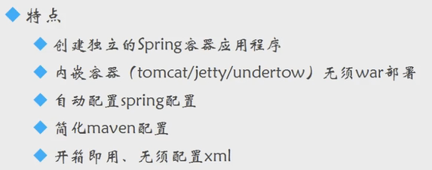

Features：

### Create stand-alone Spring applications

### Embed Tomcat, Jetty or Undertow directly (no need to deploy WAR files)

### Provide opinionated 'starter' POMs to simplify your Maven configuration

### Automatically configure Spring whenever possible

### Provide production-ready features such as metrics, health checks and externalized configuration

### Absolutely no code generation and no requirement for XML configuration